Q2(a)
$$\frac{dS}{dt}=bN+vR-\left(d+λ\right)S$$
$$\frac{dE}{dt}=λS-\left(d+α\right)E$$
$$\frac{dI}{dt}=αE-\left(d+γ\right)I$$
$$\frac{dR}{dt}=γI-\left(d+v\right)R$$
$$⇒\frac{dN}{dt}=\frac{dS}{dt}+\frac{dE}{dt}+\frac{dI}{dt}+\frac{dR}{dt}$$
$$=bN-dN=N\left(b-d\right)=0 when b=d$$
Therefore when b=d, we have rate of change of N is 0 therefore the population is static.

Q2(d)
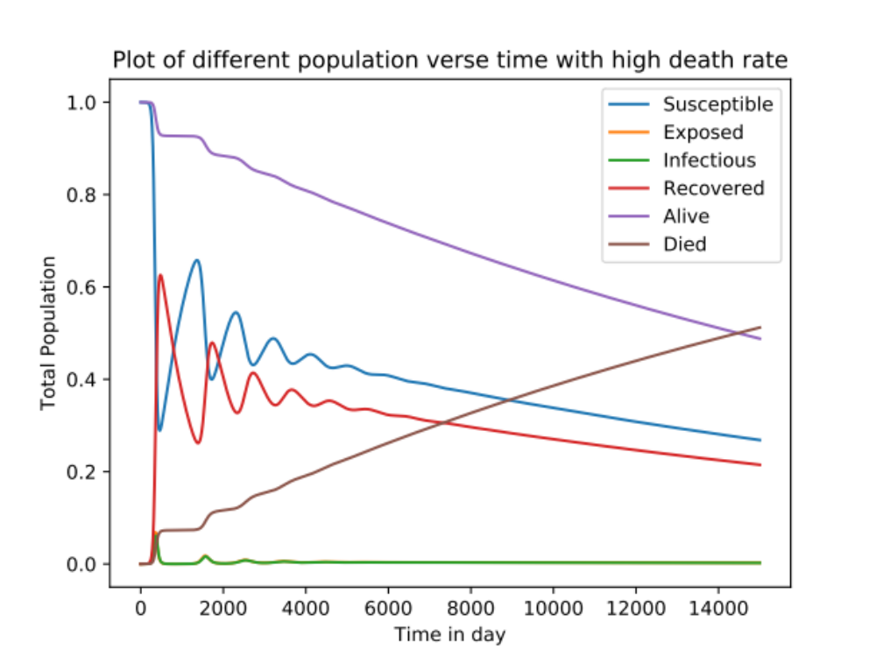
We use the time scale to 15000 days to clearly show the moment when population is fall by half. By the graph and calculation, we see notice that after 14468 days, which is around 39 years, the population of death is higher than the population of alive. That is when the population is fall by half.

Q2(e)
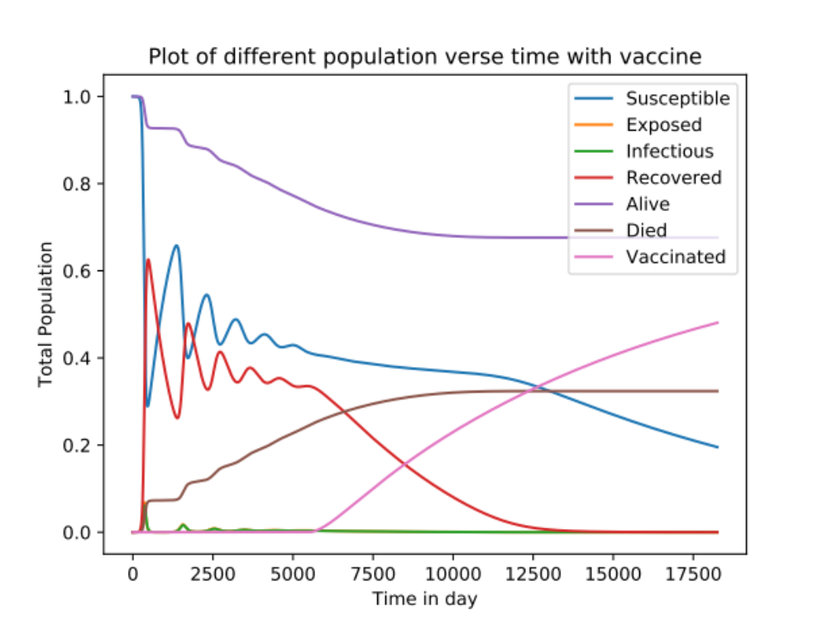
By the graph we can clearly see that although the population drops due to the high death rate when infected, but unlike Q2(d), the fall of population is quickly controlled by the effect of vaccine. Therefore the curve of alive population and death population are converging to a rate of 0.676 and 0.324 correspondingly and becoming very stable afterward.

